Data Source & Specification Document
Project: AI Powered Fashion Trend Forecasting
Version: 1.0
Version | Date | Author | Description of Changes | Reviewed By | Approval Date | Status
0.1 | 2/17/2026 |  | Initial draft created |  |  | Draft
0.2 | YYYY-MM-DD |  |  |  |  | Draft
1.0 | YYYY-MM-DD |  | First approved version |  | YYYY-MM-DD | Approved
1.1 | YYYY-MM-DD |  |  |  |  | Revised
1.2 | YYYY-MM-DD |  |  |  |  | Revised
2.0 | YYYY-MM-DD |  | Major revision |  | YYYY-MM-DD | Approved

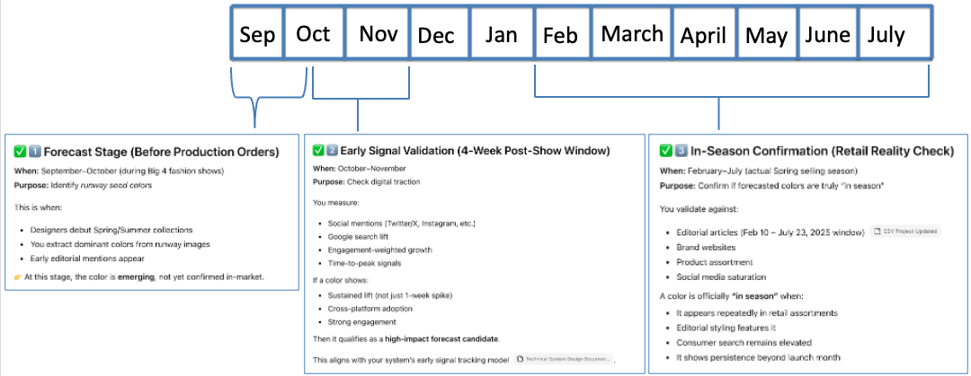
Note: From ChatGPT, Additional citation for proper terminology
- Lifecycle Stage And Where to Collect Data
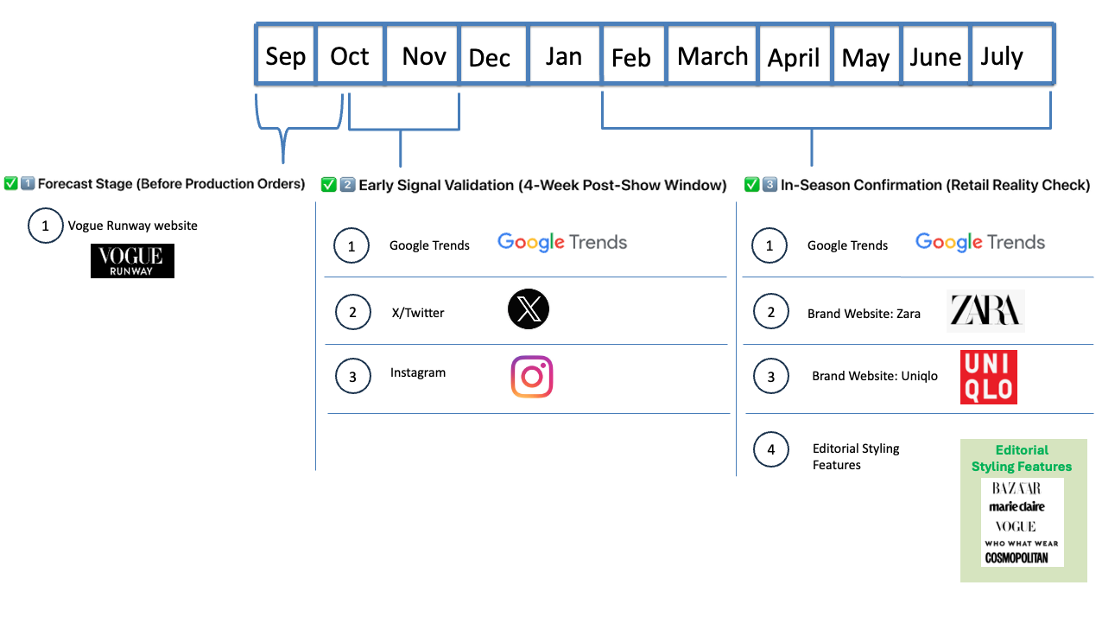

  - Forecast Stage
When: September–October (during Big 4 fashion shows)
Purpose: Identify runway seed colors
This is when:
- Designers debut Spring/Summer collections
- You extract dominant colors from runway images
- Early editorial mentions appear
👉 At this stage, the color is emerging, not yet confirmed in-market.
 | Source | Details
1 | www.vogue.com | - Access https://www.vogue.com/fashion-shows  - E-mail: admin@thefashionagents.com  - Password: p@ssw0rd
 | LIST | Search list of designers as per Annex A
 | HOW TO NAVIGATE THE WEBSITE | Step 1: Visit https://www.vogue.com/fashion-shows  Step 2: Click “Sign In” and use e-mail and password  Step 3: Click “Designers” and input designer name then select (i.e. Chanel)  Step 4: Scroll down and click “Spring 2026 Ready-to-Wear”
Raw Data Source

  - Early Signal Validation
When: October–November
Purpose: Check digital traction
You measure:
- Social mentions (Twitter/X, Instagram, etc.)
- Google search lift
- Engagement-weighted growth
- Time-to-peak signals
If a color shows:
- Sustained lift (not just 1-week spike)
- Cross-platform adoption
- Strong engagement
Then it qualifies as a high-impact forecast candidate.
Raw Data Source
 | During Spring Fashion Season | Source
1 | Twitter/X | See Annex B - List of Twitter/X Accounts
2 | Instagram | See Annex C - List of Instagram Accounts

What to Extract from X/Twitter and Instagram – See Annex D

  - In-Season Confirmation
When: February–July (actual Spring selling season)
Purpose: Confirm if forecasted colors are truly “in season”
You validate against:
- Editorial articles (Feb 10 – July 23, 2025 window)
- Brand websites
- Product assortment
- Social media saturation
A color is officially “in season” when:
- It appears repeatedly in retail assortments
- Editorial styling features it
- Consumer search remains elevated
- It shows persistence beyond launch month
Raw Data Source
 | During Spring Fashion Season | Source
1 | Website for Editorial Styling Features | See Annex E for list of websites
2 | Brand Websites | See Annex F for list of websites
3 | Google Trends | Connect to Google Trends
Editorial Ground Truth Data Capture
- Purpose (validation / labeling)
- Source (editorial articles, brand sites)
- Output table (editorial_ground_truth)
- Fields (brief)
- When it is populated (post-season)
“Generate labeled validation dataset (editorial_ground_truth) for model evaluation”
Label Definition
editorial_label = 1 if the color is confirmed in-season through editorial coverage and/or repeated brand assortment presence during the validation window
editorial_label = 0 otherwise

Annex A – List of Designers
Tier 1: Global Color Trend Setters (Must Track)
Tier 2: Strong Color Innovators (High Signal Value)
Tier 3: Emerging/ Directional Designers (Early Signal Detection)

  - Tier 1: Global Color Trend Setters (Must Track)
Fashion Show | Designers
Paris | • Chanel  • Louis Vuitton  • Dior  • Saint Laurent  • Balenciaga  • Valentino  • Givenchy  • Hermès
Milan | • Prada  • Gucci  • Bottega Veneta  • Versace  • Fendi  • Jil Sander
London | • Burberry  • JW Anderson  • Simone Rocha

  - Tier 2: Strong Color Innovators (High Signal Value)
These brands often experiment with bold palettes that create early directional shifts.
Designers
• Schiaparelli
• Rick Owens
• Miu Miu
• Dries Van Noten
• Issey Miyake
• Comme des Garçons
• Loewe
• The Row
• Coperni
• Alexander McQueen
• Acne Studios
• Jacquemus

  - Tier 3: Emerging/ Directional Designers (Early Signal Detection)
Designers
• Peter Do
• Marine Serre
• Telfar
• Christopher John Rogers
• Erdem
• Rokh
• Ottolinger
• Paloma Wool
• Ganni
• Khaite
• Molly Goddard

Annex B– List of Twitter Accounts
Tier 1: Primary Signal Drivers (High Predictive Weight)
Tier 2: Structured Diffusion Amplifiers (High Reliability)
Tier 3: Early Directional & Cultural Signals (Exploratory Weight)
Tier 1: Primary Signal Drivers (High Predictive Weight)
These accounts directly inject, validate, or strongly accelerate runway color trends.

Tier 1 – 1A | 1A. Global Fashion Authorities (Runway Amplifiers)  - @VogueRunway  - @voguemagazine  - @BoF  - @wwd  - @Pantone  - @WGSN  - @FashionSnoops | Why Tier 1?  They:  - Publish runway imagery immediately  - Frame color narratives  - Influence buyers + brands  - Create strong early engagement lift  Model Weight: Very High
Tier 1 – 1B | 1B. A-List Fashion Celebrities (Acceleration Layer)  - @Zendaya  - @dualipa  - @bellahadid  - @gigihadid  - @rihanna  - @kyliejenner  - @HaileyBieber  - @DojaCat | Why Tier 1?  Single monochrome appearance can trigger:  - Google Trends spike  - Pinterest saves surge  - Retail search lift  Model Weight: High but time-decay adjusted

Tier 2 — Structured Diffusion Amplifiers (High Reliability)
These accounts create sustained exposure and translate runway color into wearable context.
Tier 2 – 2A | Influential Editors & Critics  - @NicolePhelps  - @sarahemower  - @timblanks  - @cathyhoryn  - @lopezahmed | Model Weight: High  They provide color commentary like:  “A wave of pistachio green dominated Milan.”
Tier 2 – 2B | High-Impact Fashion Influencers  - @matildadjerf  - @emilisindlev  - @camillecharriere  - @pernilleteisbaek  - @leoniehanne  - @carodaur | Why Tier 2?  - Repeat styling of trend colors  - Strong save/share behavior  - Better persistence indicators than celebrities  Model Weight: High & persistence-weighted
Tier 2 – 2C | Major Fashion Publications (Secondary Amplifiers)  - @Dazed  - @i_D  - @AnotherMagazine  - @TheCut  - @HYPEBEAST  - @highsnobiety | Model Weight: Medium-High

Tier 3 — Early Directional & Cultural Signals (Exploratory Weight)
These are useful for detecting subculture-driven color shifts.
Tier 3 – 3A | Streetwear & Youth Culture  - @asaprocky  - @kerwinfrost  - @yoon_ambush | Model Weight: Medium
Tier 3 – 3B | Design & Visual Curators  - @designboom  - @dezeen  - @itsnicethat  - @colossal | These are strong for:  - Mood-based color shifts  - Interior ↔ fashion crossover signals
Tier 3 – 3C | Fashion Week Official Accounts  - @ParisFashionWk  - @Milano_Fashion  - @LFW  - @nyfw | Model Weight: Contextual (event-window boosted)

Annex C – List of Instagram Accounts
Tier 1: Primary Signal Drivers (High Predictive Weight)
Tier 2: Structured Diffusion Amplifiers (High Reliability)
Tier 3: Early Directional & Cultural Signals (Exploratory Weight)
Tier 1: Primary Signal Drivers (High Predictive Weight)
These accounts directly inject, validate, or strongly accelerate runway color trends.

Tier 1 – 1A | 1A. Global Fashion Authorities (Runway Amplifiers)  - @voguerunway @voguemagazine  - @businessoffashion  - @wwd  - @pantone  - @wgsn  - @tagwalk | Why Tier 1:  - Immediate runway uploads  - Editorial color framing  - High engagement density  - Strong early-season signal strength  Model Weight: Very High
1B. | Major Luxury Brands (Seed Palette Source)  - @chanelofficial  - @louisvuitton  - @dior  - @prada  - @gucci  - @balenciaga  - @valentino  - @miumiu  - @bottegaveneta  - @versace | Why Tier 1:  - Primary color injection layer  - High-quality runway imagery for CV pipeline  - Controlled, cohesive palette storytelling  Model Weight: Very High (Runway Prominence Features)

1C | A-List Fashion Celebrities (Acceleration Layer)  • @zendaya  • @dualipa  • @bellahadid  • @gigihadid  • @badgalriri  • @kyliejenner  • @haileybieber  • @dojacat  • @florencepugh  • @annehathaway | Why Tier 1:  - Red carpet monochrome moments  - Coordinated press-tour color narratives  - Massive search + save spikes  Model Weight: High (fast time-decay adjustment)

Tier 2: Structured Diffusion & Translation Layer
These accounts convert runway colors into wearable styling and sustained exposure.
2A | High-Impact Fashion Influencers  • @matildadjerf  • @emilisindlev  • @camillecharriere  • @pernilleteisbaek  • @leoniehanne  • @carodaur  • @greceghanem  • @brittanybathgate  • @symphonyofsilk | Why Tier 2:  - Repeat styling cycles  - Strong save behavior  - Higher persistence indicator than celebs  Model Weight: High (persistence-weighted)
2B | Stylists (Early Coordination Signal)  - @luxurylaw (Law Roach)  - @jasonbolden  - @andrewmukamal  - @danixmichelle  - @petraflannery | Why Tier 2:  - If multiple stylists converge on a color → early cluster signal  - Strong red carpet forecasting value  Model Weight: Medium-High

2C | Fashion Media & Visual Curators  - @dazed  - @i_d  - @anothermagazine  - @thecut  - @hypebeast  - @highsnobiety  - @itsnicethat  - @designboom | Model Weight: Medium-High

Tier 3: Cultural & Experimental Color Signals
Good for early directional detection before scaling.

3A | Streetwear & Youth Culture  - @asaprocky  - @kerwinfrost  - @yoon_ambush  - @wisdm | Model Weight: Medium
3B | Emerging Designers (Color-Forward)  - @christopherjohnrogers  - @marineserre_official  - @peterdo  - @rokhofficial  - @ottolinger  - @palomawool | Model Weight: Exploratory / Medium

Annex D – Google Trends

Option A — Official Google Trends API (best long-term, but limited access)
Google has an alpha “Google Trends API” you can apply to use.
If you get access, this is the cleanest and most compliant approach for a production system.
When to use: if you want a durable pipeline with fewer breakages.

Option B — Unofficial programmatic access (fastest to implement)

1) Python: pytrends
pytrends is the most common Python library used to programmatically pull “Interest over time”, “Interest by region”, “Related topics/queries”, etc. It’s unofficial and Google can change behavior/rate limits.
What you can extract (useful for your feature store):
- Interest over time (weekly/daily depending on range)
- Interest by region
- Related queries/topics (great for expanding your color lexicon)
- Compare multiple terms (e.g., “cobalt blue” vs “ketchup red”)
Caveat: because it’s unofficial, you should build:
- retries + backoff
- caching of results
- low request frequency
pytrends docs explicitly note it’s not official and rate limits are not published.

2) Third-party data providers (API wrapper)
Services like Apify offer a “Google Trends API” wrapper approach.
This can reduce maintenance vs rolling your own scraping, but adds vendor dependency + cost.

Option C — Manual export (most compliant, lowest automation)
Google Trends lets you download CSV directly from the UI (“Download” icon on charts).
When to use: quick MVP, human-in-the-loop validation, or building a small seed dataset.

Annex E – What to Extract from X/Twitter and Instagram
📊 X / Twitter — Data to Extract
1️⃣ Post-Level Data
Field | Type | Why It Matters | Feature Use
post_id | string | Unique identifier | Deduplication
created_at | datetime | Timestamp | Time-series, lift calc
account_handle | string | Source tracking | Tier weighting
post_type | categorical | Original / Retweet / Quote | Diffusion mapping
language | string | Filter noise | NLP cleaning
is_reply | boolean | Reduce conversational noise | Signal filtering

2️⃣ Engagement Metrics
Field | Type | Why | Feature
like_count | int | Popularity | Weighted engagement
repost_count | int | Amplification | Diffusion strength
reply_count | int | Conversation depth | Momentum
quote_count | int | Secondary amplification | Network spread
impression_count (if available) | int | Reach | Engagement rate
engagement_1h / 6h / 24h | int | Velocity | Time-to-peak

3️⃣ Content / NLP Fields
Field | Type | Why | Feature
full_text | text | Core NLP input | Color mention extraction
hashtags | array | Event tagging | Fashion-context filter
mentioned_accounts | array | Designer/celebrity links | Cascade modeling
detected_colors | array | Standardized color lexicon | Core signal
sentiment_score | float | Tone detection | Spike validation
fashion_context_score | float | Filter non-fashion usage | Noise control

4️⃣ Image-Level (If Media Attached)
Field | Type | Why | Feature
image_url | string | Asset reference | CV ingestion
dominant_colors_lab | array | Color extraction | Visual signal
color_proportion | float | Strength of color | Weighted presence
brightness | float | Mood detection | Mood board input

5️⃣ Account-Level Data
Field | Type | Why | Feature
follower_count | int | Authority | Authority score
avg_engagement_rate | float | Reliability | Tier weighting
verified_status | boolean | Credibility | Weight adjustment
account_tier | int (1–3) | Influence ranking | Base weight

6️⃣ Derived Twitter Metrics
Metric | Formula | Purpose
weighted_engagement | engagement × authority_score | Signal strength
velocity_score | engagement_24h / engagement_total | Diffusion speed
spike_flag | z-score threshold | Momentum detection
diffusion_cascade_depth | retweet network depth | Spread modeling

📸 Instagram — Data to Extract
Instagram is more visual + persistence-driven.

1️⃣ Post-Level Data
Field | Type | Why | Feature
post_id | string | Unique ID | Deduplication
created_at | datetime | Timestamp | Baseline vs lift
post_type | categorical | Feed / Reel / Carousel | Engagement weighting
caption_text | text | NLP input | Color + theme extraction
tagged_accounts | array | Designer links | Cascade mapping

2️⃣ Engagement Metrics
Field | Type | Why | Feature
like_count | int | Popularity | Weighted signal
comment_count | int | Depth | Momentum
save_count (if accessible) | int | Persistence | Adoption predictor
share_count (if accessible) | int | Spread | Diffusion
engagement_24h | int | Early spike | Velocity
⚠ Instagram saves are especially powerful for forecasting.

3️⃣ Image / Video CV Fields (Very Important)
Field | Type | Why | Feature
media_url | string | Asset ingestion | CV processing
dominant_colors_lab | array | Core color extraction | Visual signal
color_distribution | array | Multi-color presence | Palette detection
saturation | float | Bold vs muted | Trend type
color_cluster_id | string | Repeated cluster detection | Momentum grouping

4️⃣ Account-Level Data
Field | Type | Why | Feature
follower_count | int | Authority | Weighting
avg_engagement_rate | float | Reliability | Influence score
account_category | categorical | Brand / Celeb / Influencer | Tier logic
account_tier | int | Influence ranking | Base weight

5️⃣ Derived Instagram Metrics
Metric | Formula | Purpose
ig_persistence_score | saves / followers | Long-term signal
repeat_exposure_count | # of posts featuring same color | Adoption indicator
stylist_cluster_score | shared color across stylists | Coordination signal
brand_to_influencer_lag | time difference | Diffusion speed

🔄 Cross-Platform Alignment (Important)
To support your engineered_features table , standardize:
Unified Field | Twitter | Instagram
platform | twitter | instagram
color_standardized | ✔ | ✔
weighted_engagement | ✔ | ✔
velocity_score | ✔ | ✔
persistence_score | limited | strong
diffusion_lag | ✔ | ✔

🎯 Key Strategic Difference
Platform | Strength | Use In Model
Twitter | Early spike detection | Time-to-peak predictor
Instagram | Persistence & aesthetic clustering | High-impact classifier
Google Trends | Commercial validation | Final confirmation layer

2025 - Forecast Stage

2025 Spring/Summer Fashion Show
Fashion Show | Date Publication | URL
New York | Sept 12, 2024 | https://www.whowhatwear.com/new-york-fashion-week-trends-spring-summer-2025
London | Sept 19, 2024 | https://www.whowhatwear.com/fashion/runway/london-fashion-week-trends-spring-summer-2025
Milan | Sept 25, 2024 | https://www.whowhatwear.com/fashion/runway/milan-fashion-week-spring-summer-2025-trends
Paris | Oct 5, 2024 | https://www.whowhatwear.com/fashion/runway/paris-fashion-week-trends-spring-summer-2025

Validation Stage

2025 Actual Colors – Validation Data Set
Magazine | Date Publication | URL
Bazaar | Feb 10, 2025 | https://www.harpersbazaar.com.sg/fashion/news-trends/15-springsummer-2025-trends-you-need-know
Marie Claire | May 22, 2025 | https://www.marieclaire.com/fashion/summer-2025-fashion-trends/
Who  What  Wear | July 10, 2025 | https://www.whowhatwear.com/fashion/outfit-ideas/summer-outfit-ideas-2025
Vogue | July 23, 2025 | https://www.vogue.com/article/summer-trends-editor-picks-2025

🐦 Twitter (X) — 5 Accounts (Balanced Like Fu)
These mirror Fu’s influencer mix.

1️⃣ @VogueRunway
Runway amplification layer (editorial framing)

2️⃣ @BoF
Industry analysis & trend commentary

3️⃣ @Pantone
Color authority (direct color signal)

4️⃣ @bryanboy
Fashion blogger (Fu included him)
0 fu-fisher-2023-the-value-of-s…

5️⃣ @hm
Mass-market brand (Fu sample brand)
0 fu-fisher-2023-the-value-of-s…
This gives you:
- Editorial
- Industry analysis
- Color authority
- Blogger diffusion
- Commercial retail brand
Balanced and aligned with Fu.

📸 Instagram — 5 Accounts (Modern Equivalent)
Fu did not use Instagram (Twitter only + Google SVI
0 fu-fisher-2023-the-value-of-s…
),
so this is your extension.
To mirror his structure:

1️⃣ @voguerunway
Runway seed layer

2️⃣ @pantone
Color authority

3️⃣ @businessoffashion
Industry commentary

4️⃣ @matildadjerf
Influencer diffusion layer

5️⃣ @chanelofficial
Luxury brand injection layer
This mirrors:
- Brand
- Blogger
- Media
- Authority
- Commercial scale

🎯 Why This 5+5 Set Works for Sample Data
It preserves:
- Top-down signals (brands/media)
- Bottom-up signals (influencers + engagement)
- Color authority
- Runway amplification
But keeps ingestion manageable for:
- API limits
- Schema testing
- Feature engineering
- Model validation

If you'd like, I can next:
- Create a small justification paragraph for your capstone explaining why 5 accounts are academically defensible
- Or convert this into a ready-to-insert annex section for your documentation.
Sources

Download sept 12 to Ocotber 31, 2025
TWITTER

@VogueRunway

@BoF

@Pantone

@bryanboy

@hm
—----------
INSTAGRAM

@voguerunway

@pantone

@businessoffashion

@matildadjerf

@chanelofficial

